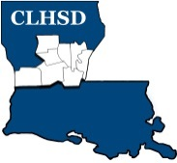
Central Louisiana Human Services District
Board Meeting Agenda
February 4, 2021

- Call to Order/Quorum
- Prayer/Pledge

- Read and Approve February 2021 Meeting Agenda (Vote)
- Solicit Public Comment Requests

- Approval of Minutes (Vote)

- January 2021 Board Meeting Minutes

- District Reports

  - Financial Report- (Vote) H1

  - ED Monthly Report H2

- Policy Reviews

Executive Limits:

  - II. E. Financial Condition & Activities w/corresponding procedure
– Non Appropriated Funds - H3

- Board Business
  - Members Term Wishes
  - Annual Bylaws Review – Kathy Scarborough, Committee Chair - H4
  - Board Development/Training Topic –Residential Treatment

- Questions/Comments as Solicited

- Next Month – March

- Executive Limits – No Executive Limits
- Board Business - Annual Retreat – To be discussed

- Training Topic – No training topic

- Announcements

Next meeting – March 4, 2020

- Adjourn (Vote)

